CSE3033 OPERATING SYSTEM PROJECT 3 REPORT
(Kevser İLDEŞ – 150116048,
Fatmanur ÖZDEMİR – 150116046)

In this project, we are required to implement thread synchronization.

Lpthread library is used and for critical sections we used binary semaphores.

We used array structure to store lines read from file.

Firstly, it checks the number of arguments given and if it is not true informs the user about format.

Next, it counts the number of lines ( to know when to exits a thread – after all lines are done –)

Then, according to arguments given, we initialized semaphores and create and initialized threads with pthread library structure.

There are 4 type of threads and read-write and upper-replace threads should be checked and controlled in entering critical section.

To do this we used a lock between read and write threads, that is reading and writing can not be in the same time.

Then, after there is at least one entry in array replace and upper threads should modify lines. But they cannot modify same line at the same time, we used while loop to prevent if there is other type of modification thread in the same line.

Besides, there are different lock mechanisms for each kind of threads separately as they update common variable (index and number).

In read function, in critical section it assigns the index number to thread which line to store which index ( first empty). Then, it reads next line of the file with fgets function and stores it to array.

In upper function, it firstly check if there is at least an entry in the array and after that, it again enters the critical section increments the index and then with toupper function it makes line at that index of the array all uppercase char by char.

In replace function, it is similar to the upper function, it just replaces all spaces with underscore after checking line char by char.

In write function, after it checks if there is at least one element that all modifications are made, it finds the line in that index with fseek function then it prints the modified line to the file with fprintf function.

Example run:
deneme.txt before execution
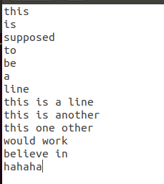

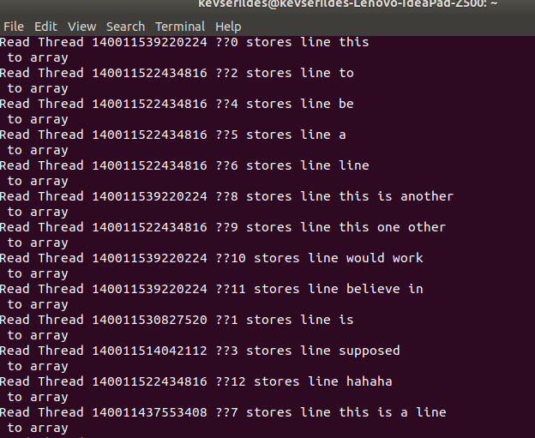

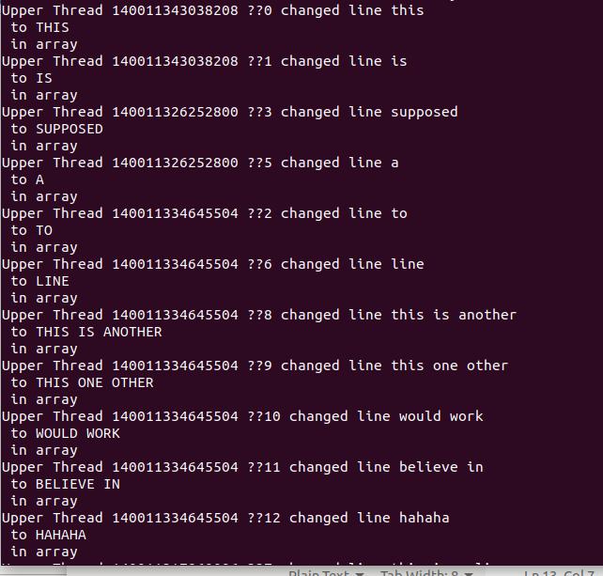

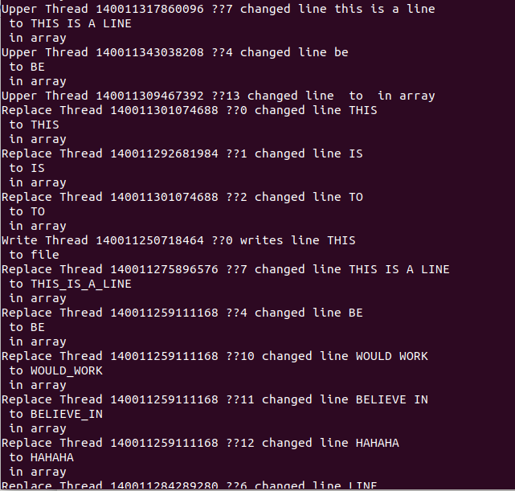

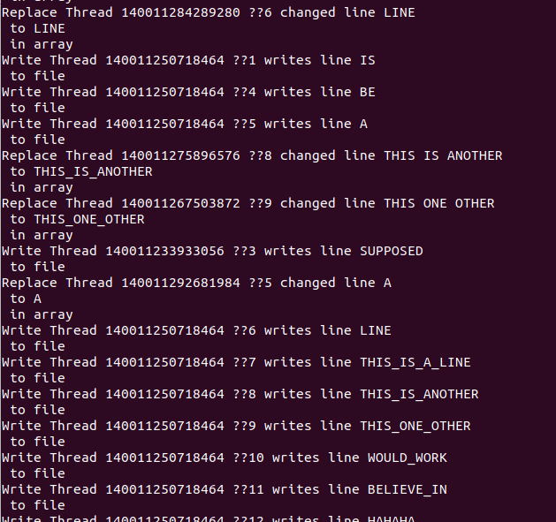

deneme.txt after execution
